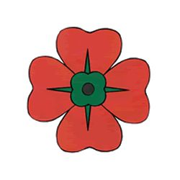::::::::::::::::::: 4th

**PARISH PHONE**

Praise the Lord! The Parish Landline 92951059 is back up and running. We have a better line and a new answering machine. My apologies for any inconvenience to you, particularly those who rang and left messages over the past 10 days.

**FINANCIAL CONTRIBUTIONS TO THE CHURCH**

I have had lots of people ask me this past week about making financial contributions to Sacred Heart Catholic Church. Should you wish to make a contribution to either the First or Second Collection I have included the account details below.

**Second Collection**

**Parish Account details:**

BSB 086 006

673418807

**First Collection**

**Presbytery Account details:**

BSB 086 006

551882740



**GREETINGS FROM FR JOHN**

I can scarce believe that Easter happened last weekend! The days pass quickly despite being limited in what we can do. I spoke to quite a lot of parishioners via phone and email over the past week and I can gladly report that everyone is well. My concern had been that there would be people who were isolated within the broader context of isolation but was delighted to discover that everyone seems to have someone. If you do know of anyone (parishioner or not) who is in need of assistance, I am quite happy to channel my efforts and resources in their general direction. One of our parishioners is in need of prayers: Her name is Biddie Bowen and she has just been moved to a hospice to see out her final days. Please pray for her, her husband Graham and the family in this difficult and yet blessed time.

One of the things I am coming to see is that while we have been coping well with this imposed isolation…the longer it continues, the more difficult it becomes. I suppose there are only so many jobs we can busy ourselves with around the house. Our places of residence have possibly never been cleaner! I think the challenge is to have a structured day incorporating different activities like reading, cleaning, sitting quietly in prayer in the garden, and creative expression: in way that we cook or reach out to other people or improve the way we live, not only during this time…but beyond.

I think our Archbishop was delighted to learn that more than 20,000 people tuned in to each of the various services throughout the Easter Triduum. There is such a powerful and palpable sense of us being the Mystical Body of Christ when we are gathered together, not only in faith, but in prayer and worship as well! We draw strength and inspiration from each other as we are called to transcend ourselves and share the very essence of who we are with the world; even during COVID-19

**NEWS, HAPPENINGS & CELEBRATIONS**

**PARISH PRIEST: FR JOHN DALY – 9295 1059**

**Address: 200 Coolgardie Street, Mundaring, 6073**

**Parish Email:** [sacredheartmundaring@westnet.com.au](mailto:sacredheartmundaring@westnet.com.au)

**Website:** [**www.sacredheartmundaring.com.au**](http://www.sacredheartmundaring.com.au)

**Parish Pastoral Care Coordinator:** Deacon Paul Reid**-** 0455 818 718

**Email: sacredheartdeacon@westnet.com.au**

**Next Week’s Bulletin Editor**: Kaye Lynam – 9298 8088

**Bulletin Notices:** Call, or email, the Editor **by 5:00pm Thursday**

**Bulletin Email:** [hillsflock@westnet.com.au](mailto:hillsflock@westnet.com.au)

LOVE

LkOVEl

**sses or wait until next weekend. I shall advise you next weekend when our first meetings will be**

**SACRED HEART PARISH - MUNDARING**



[This Photo](http://dipteeraut.blogspot.com/2013/05/coffee.html) by Unknown Author is licensed under [CC BY-SA-NC](https://creativecommons.org/licenses/by-nc-sa/3.0/)

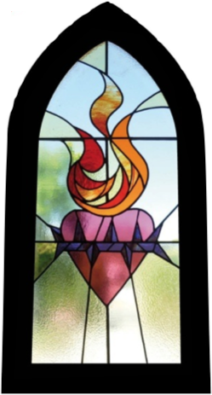

THIS WEEKEND – THE FIRST WEEKEND OF THE MONTH – JOIN US AFTER MASS FOR OUR MONTHLY “CUPPA”

There is also a Direct Debit option available: should you wish to pursue this avenue email Fr John at [jadaly13@hotmail.com](mailto:jadaly13@hotmail.com) and I will send you a form.

The times we live in are unusual to say the least and I understand that many will be unable to make any contribution. This message is for those who want, of their own volition, to continue this practice during these days.



[This Photo](http://bahbs.wordpress.com/2010/11/11/lest-we-forget/) by Unknown Author is licensed under [CC BY-NC-ND](https://creativecommons.org/licenses/by-nc-nd/3.0/)

**Reconciliation**

I am available for the Sacrament of Reconciliation:

**Anointing of the Sick and Last Rites**

I am also able to celebrate the Sacrament of the Sick and Dying.

Ring me on 9298 1059 I will strive to meet your spiritual needs.

**Two Responses to the Light**

**DAILY MASSES**

**Go to** [**www.perthcatholic.org.au**](http://www.perthcatholic.org.au) **double click on the Live Stream icon and access the Daily Mass from Perth celebrated at 12.10pm each weekday.**

**OR**

You can also go to [www.wordonfire.org](http://www.wordonfire.org) scroll down and access Mass from Bishop Barron’s Chapel **(Daily Mass)**…obviously this link will have a different time zone!

**OR**

**SUNDAY ONLY (for those who no internet)**

**Free-to-Air Television ‘Mass for You at Home’** which airs on **Channel 10: Sunday mornings at 6am**

**ONLINE MASSES**

**There are many options for either Daily or Sunday Mass online and I have listed some below. As I prayed this week I started to become conscious of the importance of tuning in to our own Archdiocesan Masses. I love Bishop Barron at Word on Fire (**and that still may be part of my ‘Covid’ journey**), yet there is a sense of us being bound together as the Mystical Body of Christ in this place when we gather. We don’t get a lot of opportunities to gather as an Archdiocese, so this time and circumstance gifts us with a terrific opportunity to be together in prayer and in the Mass.** Take the time to prepare as you would for Mass: avoid the temptation to lounge on the couch, but rather behave as you would at Mass…standing, kneeling and sitting: kneeling during the Eucharistic Prayer especially!

You will be nourished by the Word read and the Homily given and you can enter into what we call a spiritual communion. You could say a prayer of spiritual communion as the celebrant receives the Body and Blood of Christ.

*My Jesus,   
I believe that You  
are present in the Most Holy Sacrament.   
I love You above all things,   
and I desire to receive You into my soul.   
Since I cannot at this moment  
receive You sacramentally,   
come at least spiritually into my heart. I embrace You as if You were already there and unite myself wholly to You. Never permit me to be separated from You.*

*Amen.*

**SECOND SUNDAY OF EASTER – YEAR A**

**SECOND SUNDAY OF EASTER – YEAR A**

**In today’s Gospel story, the blind man’s physical disability is relieved in the opening scene. But his journey to the light (of day) in this physical sense is only a symbol of a much longer journey that he then begins: a journey out of the darkness of unbelief to discovery of the Light of the world in the person of Jesus.**

**While Jesus’ role in the episode is crucial, he appear only at its beginning and end. In between the healed man – and his parents- engage in a battle with the religious authorities. These instantly strive to get him to deny the truth of what Jesus has done for him. Far from discouraging him, however, the intensifying hostility only propels him on a journey of ever growing faith that comes to a climax when he falls down and worships Jesus.**

**CARITAS AUSTRALIA** would like to **THANK YOU** for supporting Project Compassion 2020. Thank you for supporting us this year as we demonstrate how love and compassion for our global community can transform lives.

**COVID-19** means that churches are temporarily closed for parish Masses. During this time may we ask that **cash** donations in Project Compassion boxes or envelopes be sent to us by cheque or credit card instead.

Please **either** mail to:

Caritas Australia, 40A Mary Street, HIGHGATE WA 6003. (Please do not send **cash** in the mail. Also, include your completed box top or envelope if you need a tax receipt.)

**or**: visit [www.caritas.org.au/projectco](http://www.caritas.org.au/projectco)mpassion to make your donation online.

**or:** by phone 08 9422 7925. This is Caritas’ Highgate WA office. Calls are forwarded to Deacon Paul Reid, during COVID-19 office closure.

**or:** 1800 024 413 This is Caritas’ National Office.

**Thank you for supporting Caritas Australia’s Project Compassion 2020 appeal.**

[**www.caritas.org.au/projectcompassion**](http://www.caritas.org.au/projectcompassion) **#projectcompassion 1800 024 413**

**An attractive feature is the way the man’s character emerges as the story develops. Questioned about how he came to be cured, he never goes beyond the evidence; he simply sticks to the facts and draws the inescapable conclusions. His journey into faith is a journey into ever deeper perception of reality.**

**The adversaries on the other hand, resort to denial of the obvious facts, then to unfounded accusations and personal abuse. Finally, they appeal simply to their own authority and status. While the man comes to the Light, they – despite their physical ability to see – journey to the darkness of sin and unreality.**

**Going in opposite directions the two journeys dramatically illustrate two responses to Jesus as Light of the world.**

**WORDS FROM POPE FRANCIS**

“This moment in history is ‘a time to choose what matters in life and what passes away, a time to separate what is necessary from what is not. It is a time to get our lives back on track with regard to You, Lord, and to others’.”

[**CLICK HERE**](https://drive.google.com/open?id=1h5lJhkD-fBkgU5kw6s-CxmXhTcEhYQ9Z) **FOR FATHER JOHN’S HOMILY**

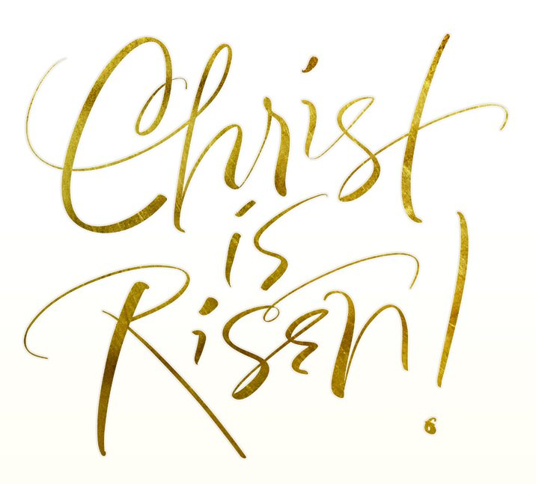

3. The stone which the builders rejected

Has become the corner stone.

This is the work of the Lord,

A marvel in our eyes.

This day was made by the Lord,

We rejoice and are glad. R

**COLLECT:** God of everlasting mercy, who in the very recurrence of the paschal feast kindle the faith of the people you have made your own, increase, we pray, the grace you have bestowed, that all may grasp and rightly understand in what font they have been washed, by whose Spirit they have been reborn, by whose Blood they have been redeemed. Through our Lord Jesus Christ, your Son, who lives and reigns with you in the unity of the Holy Spirit, one God, for ever and ever.

**First Reading: A reading from the Acts of the Apostles** 2: 42-47

*The faithful lived together and owned everything in common.*

The whole community remained faithful to the teaching of the apostles, to the brotherhood, to the breaking of bread and to the prayers. The many miracles and signs worked through the apostles made a deep impression on everyone. The faithful all lived together and owned everything in common; they sold their goods and possessions and shared out the proceeds among themselves according to what each one needed. They went as a body to the Temple every day but met in their houses for the breaking of bread; they shared their food gladly and generously; they praised God and were looked up to by everyone. Day by day the Lord added to their community those destined to be saved. **The word of the Lord.**

**Responsorial Psalm:** Ps 117:2-4, 13-15, 22-24

R. **Give thanks to the Lord for he is good, his love is everlasting.**

1. Let the sons of Israel say:

‘His love has no end.’

Let the sons of Aaron say:

‘His love has no end.’

Let those who fear the Lord say:

‘His love has no end.’ R

1. I was thrust, thrust down and falling

But the Lord was my helper.

The Lord is my strength and my song:

He was my saviour.

There are shouts of joy and victory

In the tents of the just. R

**Second Reading: A reading from the first letter of St Peter 1: 3-9**

*He has given us a new birth as his children, by raising Jesus Christ from the dead.*

Blessed be God the Father of our Lord Jesus Christ, who in his great mercy has given us a new birth as his sons, by raising Jesus Christ from the dead, so that we have a sure hope and the promise of an inheritance that can never be spoilt or soiled and never fade away because it is being kept for you in the heavens. Through your faith, God’s power will guard you until the salvation which had been prepared is revealed at the end of time. (***Continued next page)***

***Second Reading Continued:***

This is a cause of great joy for you, even though you may for a short time have to bear being plagued by all sorts of trials; so that, when Jesus Christ is revealed, your faith will have been tested and proven like gold – only it is more precious than gold, which is corruptible even though it bears testing by fire – and then you will have praise and glory and honour. You did not see him, yet you love him; and still without seeing him, you are already filled with joy so glorious that it cannot be described, because you believe; and you are sure of the end to which your faith looks forward, that is, the salvation of your souls. **The word of the Lord.**

**Gospel Acclamation:** 1 Cor 5:7-8

Alleluia, alleluia! You believe in me, Thomas, because you have seen me; happy those who have not seen me, but still believe! Alleluia!

**GOSPEL: A reading from the holy Gospel according to John** **20: 19-31**

*After eight days, Jesus came in a stood among them.*

In the evening of that same day, the first day of the week, the doors were closed in the room where the disciples were, for fear of the Jews. Jesus came and stood among them. He said to them, ‘Peace be with you,’ and showed them his hands and his side. The disciples were filled with joy when they saw the Lord, and he said to them again,

‘Peace be with you.’

‘As the Father sent me, so am I sending you.’

After saying this he breathed on them and said:

‘Receive the Holy Spirit.

For those whose sins you forgive,

They are forgiven:

For those whose sins you retain,

They are retained.’

Thomas, called the Twin, who was one of the Twelve, was not with them when Jesus came. When the disciples said, ‘We have seen the Lord,’ he answered, ‘Unless I see the holes that the nails made in his hands and can put my finger into the holes they made, and unless I can put my hand into his side, I refuse to believe.’ Eight days later the disciples were in the house again and Thomas was with them. The doors were closed, but Jesus came in and stood among them. ‘Peace be with you,’ he said. Then he spoke to Thomas, ’Put your finger here; look, here are my hands. Give me your hand; put it into my side. Doubt no longer but believe.’ Thomas replied, ‘My Lord and my God!’ Jesus said to him: You believe because you can see me. Happy are those who have not seen and yet believe.’

There were many other signs that Jesus worked, and the disciples saw, but they are not recorded in this book. These are recorded so that you may believe that Jesus is the Christ, the Son of God, and that believing this you may have life through his name.

**The Gospel of the Lord**.

**SECOND SUNDAY OF EASTER – YEAR A**

**SECOND SUNDAY OF EASTER – YEAR A**