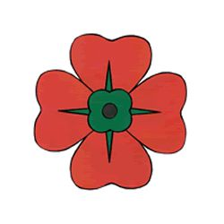::::::::::::::::::: 4th

**FINANCIAL CONTRIBUTIONS TO THE CHURCH**

I have had lots of people ask me this past week about making financial contributions to Sacred Heart Catholic Church. Should you wish to make a contribution to either the First or Second Collection I have included the account details below.

**Second Collection**

**Parish Account details:**

BSB 086 006

673418807

**First Collection**

**Presbytery Account details:**

BSB 086 006

551882740

**IF YOU NEED HELP DUE TO SELF-ISOLATION OR WOULD LIKE TO TALK WITH FATHER JOHN WITH REGARD TO THESE MATTERS, PLEASE FEEL FREE TO DO SO ON 9295 1059**

I WOULD BE DELIGHTED TO SERVE YOU!

**PARISH PHONE**

Praise the Lord! The Parish Landline 9295 1059 is back up and running. We have a better line and a new answering machine. My apologies for any inconvenience to you, particularly those who rang and left messages over the past 10 days.

**I WISH YOU ALL A HAPPY AND HOLY EASTER**

Celebrating Ash Wednesday Mass, in a small hotel room in the fishing village of Finisterre, on the western edge of Northern Spain…I had No Idea what was to come. The Coronavirus was somewhere else then…Only 25 cases in Spain on Ash Wednesday *(thanks to statistics I didn’t know then).* Since my departure from Spain, more than 15,000 people have lost their lives *(due to Covid-19)* in that beautifully hospitable country. More than 90,000 people worldwide!

The season of Lent became a journey into Isolation for our own good and the good of all. Strangely enough, that's what the season of Lent was always about: us, as disciples of Jesus spending time in the ‘desert’ listening to the gentle, healing voice of God’s Spirit, calling us to a more loving existence. You could say that a more authentic Lenten journey has been forced on us by circumstance. Take time to look around you and listen to the sounds you hear and the aromas you smell; the images you see and the kindness you encounter. There is a lot to occupy our senses and to move our being!

Sure, we have been deprived on many things we took for granted; but are we substantially less because of that? Maybe we’ve become more! I think the greatest deprivation as Catholics has been from attending the Mass and receiving Holy Communion. As a priest, I have been deprived of celebrating the Mass with you, the parishioners of Sacred Heart, the people entrusted to my pastoral care. This enforced hiatus may well alert us to the importance of the Mass in our lives…not that you didn’t have that before…but a new sharper appreciation that comes from experiencing absence.

Many of you tuned in to the Holy Week services from St Mary’s Cathedral in Perth or from some other online or TV source. I had the responsibility of praying these services here alone for all in this place and while it was starkly different, I felt a compelling sense of your presence.

**I wish you all a Happy and Holy Easter and certainly look forward to being able to swing wide the doors of the church in welcome to you all…when the dust settles and the curve bottoms out!**

**NEWS, HAPPENINGS & CELEBRATIONS**

**PARISH PRIEST: FR JOHN DALY – 9295 1059**

**Address: 200 Coolgardie Street, Mundaring, 6073**

**Parish Email:** [sacredheartmundaring@westnet.com.au](mailto:sacredheartmundaring@westnet.com.au)

**Website:** [**www.sacredheartmundaring.com.au**](http://www.sacredheartmundaring.com.au)

**Parish Pastoral Care Coordinator:** Deacon Paul Reid**-** 0455 818 718

**Email: sacredheartdeacon@westnet.com.au**

**Next Week’s Bulletin Editor**: Kaye Lynam – 9298 8088

**Bulletin Notices:** Call, or email, the Editor **by 5:00pm Thursday**

**Bulletin Email:** [hillsflock@westnet.com.au](mailto:hillsflock@westnet.com.au)

LOVE

LkOVEl

**sses or wait until next weekend. I shall advise you next weekend when our first meetings will be**

**SACRED HEART PARISH - MUNDARING**



[This Photo](http://dipteeraut.blogspot.com/2013/05/coffee.html) by Unknown Author is licensed under [CC BY-SA-NC](https://creativecommons.org/licenses/by-nc-sa/3.0/)

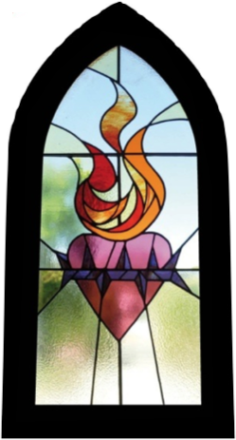

THIS WEEKEND – THE FIRST WEEKEND OF THE MONTH – JOIN US AFTER MASS FOR OUR MONTHLY “CUPPA”



[This Photo](http://bahbs.wordpress.com/2010/11/11/lest-we-forget/) by Unknown Author is licensed under [CC BY-NC-ND](https://creativecommons.org/licenses/by-nc-nd/3.0/)

There is also a Direct Debit option available: should you wish to pursue this avenue email Fr John at [jadaly13@hotmail.com](mailto:jadaly13@hotmail.com) and I will send you a form.

The times we live in are unusual to say the least and I understand that many will be unable to make any contribution. This message is for those who want, of their own volition, to continue this practice during these days.

**Two Responses to the Light**

**DAILY MASSES**

**Go to** [**www.perthcatholic.org.au**](http://www.perthcatholic.org.au) **double click on the Live Stream icon and access the Daily Mass from Perth celebrated at 12.10pm each weekday.**

**OR**

You can also go to [www.wordonfire.org](http://www.wordonfire.org) scroll down and access Mass from Bishop Barron’s Chapel **(Daily Mass)**…obviously this link will have a different time zone!

**OR**

**SUNDAY ONLY (for those who no internet)**

**Free-to-Air Television ‘Mass for You at Home’** which airs on **Channel 10: Sunday mornings at 6am**

**Reconciliation**

I am available for the Sacrament of Reconciliation:

**Anointing of the Sick and Last Rites**

I am also able to celebrate the Sacrament of the Sick and Dying.

Ring me on 9298 1059 I will strive to meet your spiritual needs.

**ONLINE MASSES**

**There are many options for either Daily or Sunday Mass online and I have listed some below. As I prayed this week I started to become conscious of the importance of tuning in to our own Archdiocesan Masses. I love Bishop Barron at Word on Fire (**and that still may be part of my ‘Covid’ journey**), yet there is a sense of us being bound together as the Mystical Body of Christ in this place when we gather. We don’t get a lot of opportunities to gather as an Archdiocese, so this time and circumstance gifts us with a terrific opportunity to be together in prayer and in the Mass.** Take the time to prepare as you would for Mass: avoid the temptation to lounge on the couch, but rather behave as you would at Mass…standing, kneeling and sitting: kneeling during the Eucharistic Prayer especially!

You will be nourished by the Word read and the Homily given and you can enter into what we call a spiritual communion. You could say a prayer of spiritual communion as the celebrant receives the Body and Blood of Christ.

*My Jesus,   
I believe that You  
are present in the Most Holy Sacrament.   
I love You above all things,   
and I desire to receive You into my soul.   
Since I cannot at this moment  
receive You sacramentally,   
come at least spiritually into my heart. I embrace You as if You were already there and unite myself wholly to You. Never permit me to be separated from You.*

*Amen.*

**EASTER SUNDAY MASS**

**EASTER SUNDAY MASS**

**In today’s Gospel story, the blind man’s physical disability is relieved in the opening scene. But his journey to the light (of day) in this physical sense is only a symbol of a much longer journey that he then begins: a journey out of the darkness of unbelief to discovery of the Light of the world in the person of Jesus.**

**While Jesus’ role in the episode is crucial, he appear only at its beginning and end. In between the healed man – and his parents- engage in a battle with the religious authorities. These instantly strive to get him to deny the truth of what Jesus has done for him. Far from discouraging him, however, the intensifying hostility only propels him on a journey of ever growing faith that comes to a climax when he falls down and worships Jesus.**

**An attractive feature is the way the man’s character emerges as the story develops. Questioned about how he came to be cured, he never goes beyond the evidence; he simply sticks to the facts and draws the inescapable conclusions. His journey into faith is a journey into ever deeper perception of reality.**

**Happy Easter from all at Caritas Australia!**

Thank you for supporting us this year as we demonstrate how love and compassion for our global community can transform lives.

**COVID-19** means that churches are temporarily closed for parish Masses. During this time may we ask that **cash** donations in Project Compassion boxes or envelopes be sent to us by cheque or credit card instead.

Please **either** mail to:

Caritas Australia, 40A Mary Street, HIGHGATE WA 6003.

(Please do not send **cash** in the mail.

Also, include your completed box top or envelope if you need a tax receipt.)

**or**: visit [www.caritas.org.au/projectco](http://www.caritas.org.au/projectco)mpassion to make your donation online.

**or:** by phone 08 9422 7925. This is Caritas’ Highgate WA office. Calls are forwarded to Deacon Paul Reid, during COVID-19 office closure.

**or:** 1800 024 413 This is Caritas’ National Office.

**Thank you for supporting Caritas Australia’s Project Compassion 2020**

**Lenten appeal.**

www.caritas.org.au/projectcompassion #projectcompassion 1800 024 413

**The adversaries on the other hand, resort to denial of the obvious facts, then to unfounded accusations and personal abuse. Finally, they appeal simply to their own authority and status. While the man comes to the Light, they – despite their physical ability to see – journey to the darkness of sin and unreality.**

**Going in opposite directions the two journeys dramatically illustrate two responses to Jesus as Light of the world.**

[**CLICK HERE**](https://drive.google.com/open?id=1P3T9mJPAZYXBxCUVAWzMjfMgXq5STWDS) **FOR FATHER JOHN’S HOMILY**

**FOR EASTER SUNDAY 2020**

**WORDS FROM POPE FRANCIS**

“This moment in history is ‘a time to choose what matters in life and what passes away, a time to separate what is necessary from what is not. It is a time to get our lives back on track with regard to You, Lord, and to others’.”

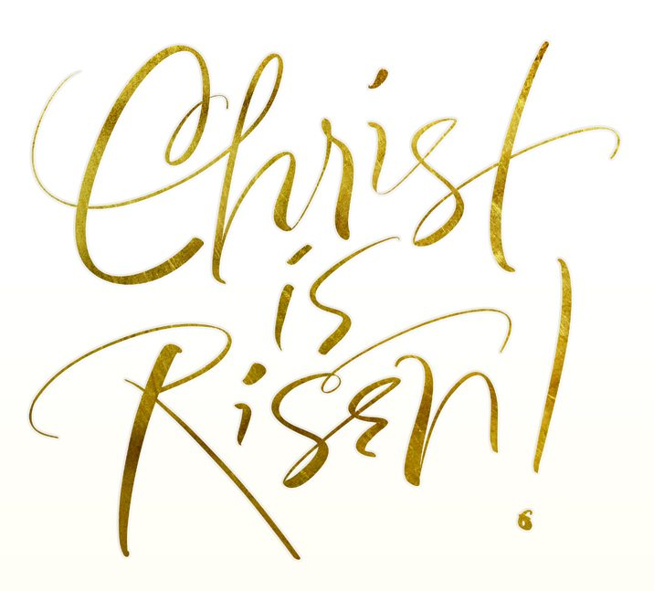



**CHRIST IS RISEN. ALLELUIA!** The empty tomb, and the neatly folded burial cloths, were signs that led the Beloved Disciple to believe that Jesus had risen from the dead. In the witness of the apostles, and the faithfulness, courage and love of our fellow Christians, we too have powerful signs that Christ is risen and lives among us. Observing them, our faith cries out: ‘Alleluia!’

**First Reading: A reading from the Acts of the Apostles** 10:34, 37-43

*We have eaten and drunk with him after his resurrection from the dead.*

Peter addressed Cornelius and his household: ‘You must have heard about the recent happenings in Judaea: about Jesus of Nazareth and how he began in Galilee, after John had been preaching baptism. God had anointed him with the Holy Spirit and with power, and because God was with him, Jesus went about doing good and curing all who had fallen into the power of the devil. Now I, and those with me, can witness to everything he did throughout the countryside of Judaea and in Jerusalem itself: and also to the fact that they killed him by hanging him on a tree, yet three days afterwards God raised him to life and allowed him to be seen, not by the whole people but only by certain witnesses God had chosen beforehand. Now we are those witnesses – we have eaten and drunk with him after his resurrection from the dead – and he has ordered us to proclaim this to his people and to tell them that God has appointed him to judge everyone, alive or dead. It is to him that all the prophets bear this witness: that all who believe in Jesus will have their sins forgiven through his name.’

**The word of the Lord.**

**Responsorial Psalm:** Ps 117:1-2, 16-17, 22-23. R. v. 24

R. **This is the day the Lord has made; let us rejoice and be glad.**

1. Give thanks to the Lord for he is good,

For his love has no end.

Let the sons of Israel say:

‘His love has no end.’ R

2. The Lord’s right hand has triumphed:

His right hand raised me up.

I shall not die, I shall live

And recount his deeds. R

**Second Reading: A reading from the letter of St Paul to the Colossians 3: 1-4**

*Look for the things that are in heaven, where Christ is.*

Since you have been brought back to true life with Christ, you must look for the things that are in heaven, where Christ is, sitting at God’s right hand. Let your thoughts be on heavenly things, not on the things that are on the earth, because you have died, and now the life you have is hidden with Christ in God. But when Christ is revealed – and he is your life – you too **wil**l be revealed in all your glory with him. **The word of the Lord.**

3. The stone which the builders rejected

Has become the corner stone.

This is the work of the Lord,

A marvel in our eyes. R

**Gospel Acclamation:** 1 Cor 5:7-8

Alleluia, alleluia! Christ has become our paschal sacrifice; let us feast with joy in the Lord. Alleluia!

**GOSPEL: A reading from the holy Gospel according to John** **20: 1-9**

*The teaching of scripture is that he must rise from the dead.*

It was very early on the first day of the week and still dark, when Mary of Magdala came to the tomb. She saw that the stone had been moved away from the tomb and came running to Simon Peter and the other disciple, the one Jesus loved. ‘They have taken the Lord out of the tomb’ she said, ‘and we don’t know where they have put him.’

So, Peter set out with the other disciple to go to the tomb. They ran together, but the other disciple, running faster than Peter, reached the tomb first; he bent down and saw the linen cloths lying on the ground, but did not go in. Simon Peter who was following now came up, went right into the tomb, saw the linen cloths on the ground, and also the cloth that had been over his head; this was not with the linen cloths but rolled up in a place by itself. Then the other disciple who had reached the tomb first also went in; he saw, and he believed. Till tis moment they had failed to understand the teaching of scripture, that he must rise from the dead.

**The Gospel of the Lord**.

**EASTER SUNDAY MASS**

**EASTER SUNDAY MASS**